Forgotten c child in a car preventer

Project Report

Students:

|  |  |
| --- | --- |
| David Dan | 301914834 |
| Dolev Vaknin | 204280481 |

Supervisor:

Boaz Mizrachi

Table of Contents

List of Figures 3

List of Tables 4

Abstract 5

List of Abbreviations 6

Introduction 7

Costs 8

# List of Figures

Figure 1 - ESP32 WROVER-B controller 7

Figure 2 - LILYGO TTGO T-Call ESP32 SIM800l v1.4 board 7

Figure 3 - MPU6050 InvenSense 8

Figure 4 -GeekCreit MPU6050 module 8

Figure 5 - MPU6050 wiring 8

Figure 6 - DHT22 module 9

Figure 7 - DHT wiring 9

Figure 8 - FSR structure 10

Figure 9 - FSR wiring 10

Figure 10 - the device on the child's safety seat 11

# List of Tables

Table 1 12

# Abstract

More than 880 children were forgotten in the car in the last decade (in Israel), more than 30 out of them died.

As for now, no solution combines low price, simple installation, and fail-proof design.

# List of Abbreviations

SoC – System on a Chip

MEMS – Micro Electrical Mechanical System

PET - Polyethylene Terephthalate

GPIO – General Purpose Input Output

ADC – Analog-Digital Converter

I2C – Inter-Integrated Circuit

SCL - Serial Clock Line

SDA - Serial Data Line

# Introduction

## ESP32

ESP32 is a series of low-cost, low-power SoC microcontrollers, with integrated Wi-Fi and dual-mode Bluetooth.

ESP32 is created and developed by Espressif Systems, a Shanghai-based Chinese company, and is manufactured by TSMC using their 40 nm process.

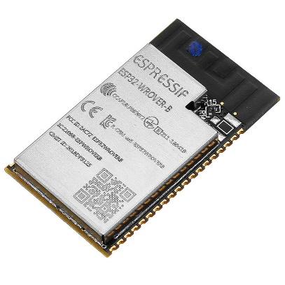

Figure - ESP32 WROVER-B controller

## LILYGO

LILYGO, also known as Shenzhen Xin Yuan Electronic Technology Co., is a company that develops and manufactures boards that include sensors and modules off the shelf.

We will use their TTGO T-Call V1.4 which contains an ESP32 WROVER-B controller and SIM800L module.

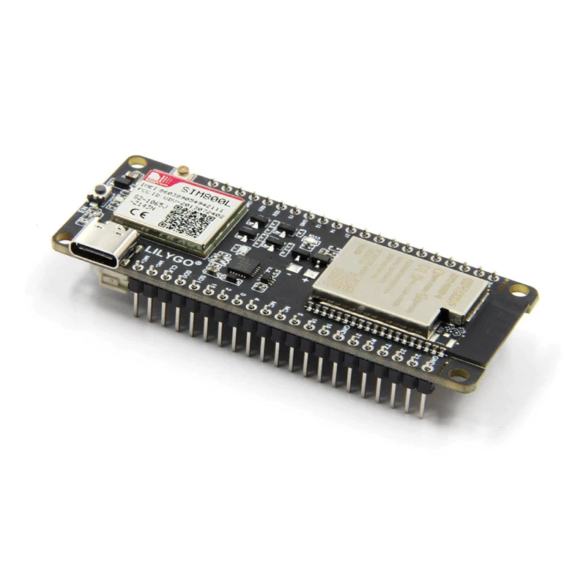

Figure - LILYGO TTGO T-Call ESP32 SIM800l v1.4 board

# Components

## MPU6050

MPU6050 is MEMS which consists of a 3-axis gyroscope and 3-axis accelerometer[1], it also provides the temperature of the module.

The MPU6050 is using the communication protocol, which uses a serial clock () and serial data () connections to communicate with our controller.

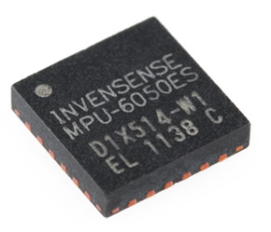

Figure - MPU6050 InvenSense

We will use a Geekcreit module that consists of the MPU6050 MEMS.

Its working temperatures are between to .

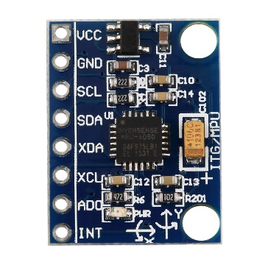

Figure -GeekCreit MPU6050 module

The wiring of the MPU6050 to the controller are as follows:

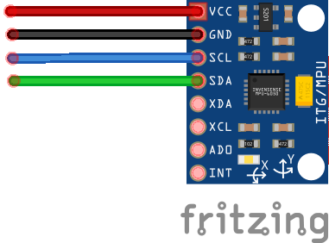

GND

3.3 V

SCL - pin 22

SDA – pin 21

Figure - MPU6050 wiring

## DHT22

DHT22 is a digital temperature and humidity sensor, it is made of two parts, a capacitive humidity sensor, and a thermistor.

Using the temperature and the humidity we can calculate the heat index, which is what the temperature feels like to the human body when relative humidity is combined with the air temperature[2].

It working temperatures are between to , with an accuracy of .

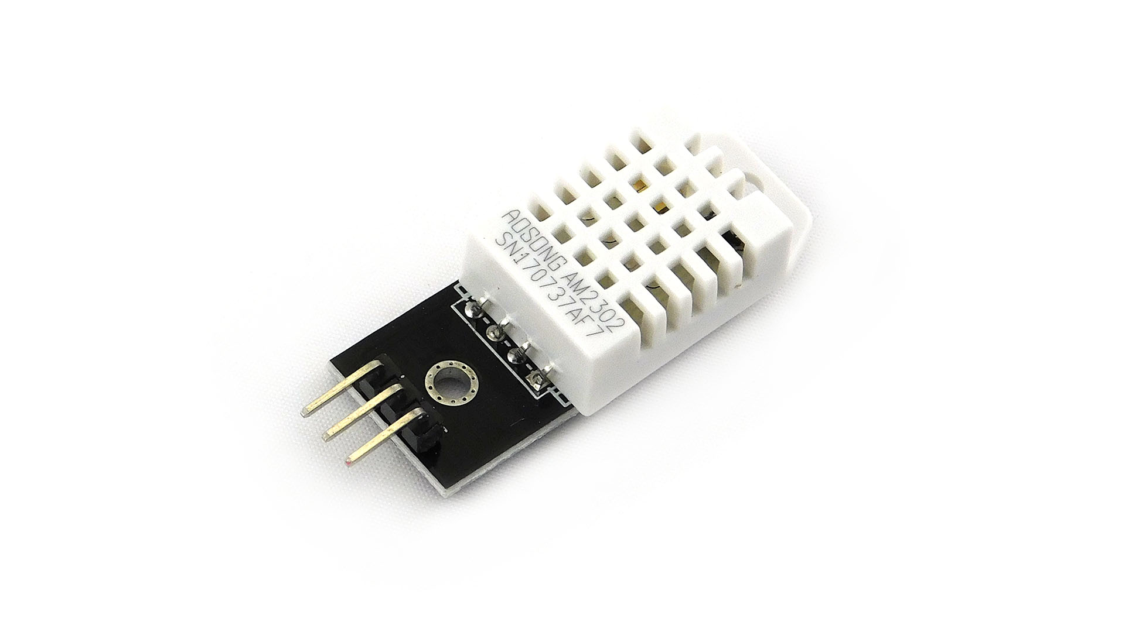

Figure - DHT22 module

The wiring of the DHT22 sensor to the controller are as follows:



3.3 V

GPIO15

GND

Figure - DHT wiring

## FSR

FSR is made of 2 layers: sensitive conductive ink, and a silver circuit. The two layers are separated by PET spacers that are connected by glue. the more one side is pushed against the other, the resistance of the sensor goes down.

We’ll use a strip sensor that can also be shortened to the required length, the sensor structure:

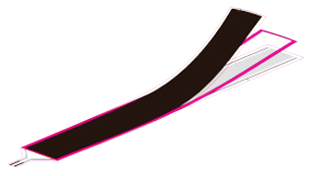

Sensitive ink

PET

Glue

PET

Silver circuit

Figure - FSR structure

The wiring of the FSR sensor to the controller are as follows:

3.3 V

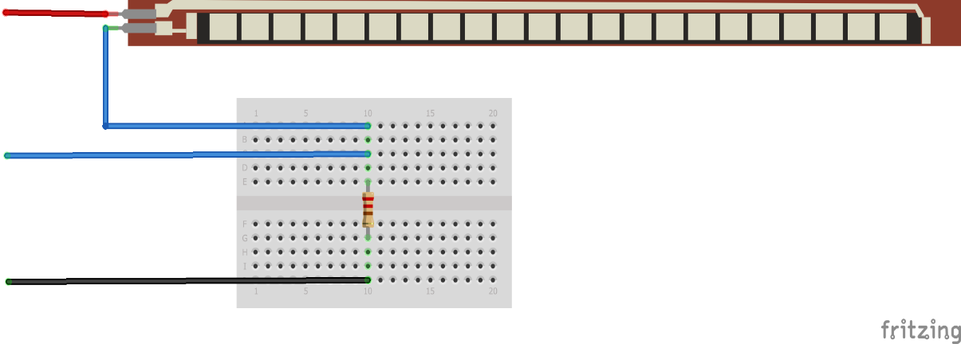

GND

ADC6 (GPI34) (gdfgfdgg(GPIO34)

Figure - FSR wiring

# Solutions

To solve the problem of a child being forgotten in the car, we need a device that will make up for all the errors of the driver:

* always work, no need to turn it on when entering the car.
* will know if there is a child in the seat, without the need to inform it manually.
* if a child was forgotten in the car:
  + make a vocal alarm.
  + send an SMS to the driver (or other family members).
* in case of increasing temperature in the car:
  + notify the driver via alarm and SMS.
* will last for months without charging or replacing the battery.

In addition, the setup of the device in the child’s safety seat should be easy, will require no special tools or knowledge, and the device could be transferable between cars or safety seats.

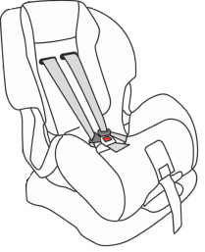

Figure - the device on the child's safety seat

# Costs

Table

|  |  |
| --- | --- |
| **Component** | **Cost** |
| Controller | ESP32 SIM800L - 12.34$ |
| Temperature sensor | 2.66$ |
| Accelerometer | 0.53$ |
| 18650 Battery (per unit) | 7.37$ |
| Dual 18650 charger | 3.05$ |
| Buzzer | 0.73$ |
| Load sensor | 2.17$ |
| Load sensor module | 0.69$ |
| Total | 36.61$ |

# Bibliography

MPU6050 - Accelerometer and Gyroscope Module [Online] // Components101. - March 7, 2018. - https://components101.com/sensors/mpu6050-module#:~:text=The%20MPU6050%20is%20a%20Micro,of%20a%20system%20or%20object.&text=The%20MPU6050%20is%20a%20Micro,of%20a%20system%20or%20object..

1. components101.com, “MPU6050 - Accelerometer and Gyroscope Module”, March 17, 2018.
2. weather.gov, “What is the heat index?”, Amarillo, TX Weather Forecast Office.